Student’s name | …………………………………………………….…… | Grade | 1
Subject | Computer | Week No. | 18
Lesson Title |  | Unit
Revision Worksheet

Question A: Match the following

 | PERSONAL COMPUTER
 | SUPER COMPUTER
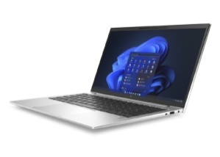 | MICRO COMPUTER
 | MINI COMPUTER
 | LAPTOP

Question B: Match the following

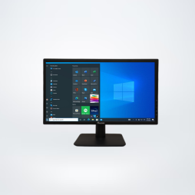 | CPU
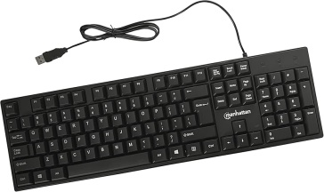 | PRINTER
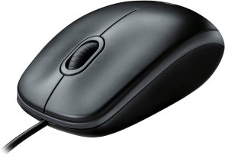 | MONITOR
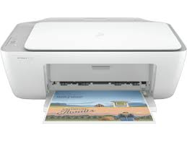 | KEYBOARD
 | MOUSE

Question C: Write the correct name of the following devices.

- 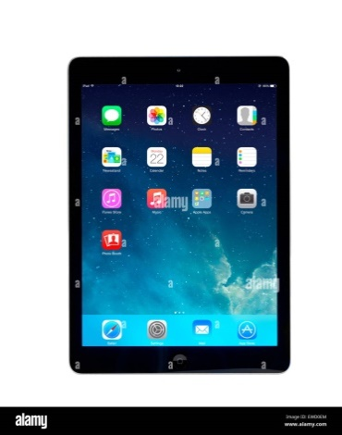 b. 
__________________ _________________

c.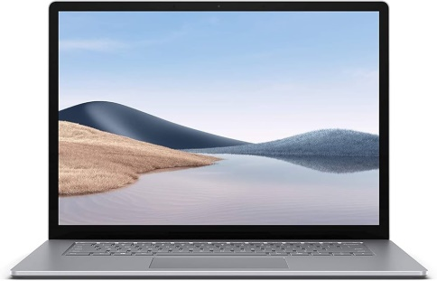 d. 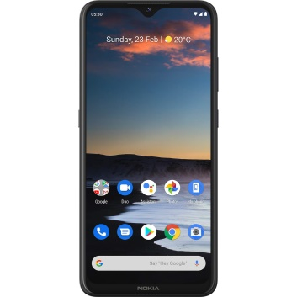

_____________________ __________________

Question D: Color the parts of computer and write their names next to it.



Instruction: State whether the below statements are True or False.

1. A mouse has two button left and right.
(a) True (b) False
2. There is no wheel at the center of the mouse.
(a) True (b) False
3. The mouse gives instructions to the computer.
(a) True (b) False
4. We can use the mouse to point out things on a computer.
(a) True (b) False
5. Dog looks like a mouse.
(a) True (b) False

Instruction: State whether the below statements are True or False.

1. Click the left button of the mouse 2 times to open the selected object.
(a) True (b) False
2. To move a file, we must drag and drop the file..
(a) True (b) False
3. Scroll wheel moves the information on a page so we can see it.
(a) True (b) False
4. Scroll is used to select an object.
(a) True (b) False
5. The touchpad on a laptop works just like a keyboard .
(a) True (b) False

ANSWER KEY
Question A: Match the following

 | PERSONAL COMPUTER
 | SUPER COMPUTER
 | MICRO COMPUTER
 | MINI COMPUTER
 | LAPTOP

Question B: Match the following

 | CPU
 | PRINTER
 | MONITOR
 | KEYBOARD
 | MOUSE

Question C: Write the correct name of the following devices.

-  b. 
Tablet Desktop

c. d. 

Smartphone Laptop

Question D: Color the parts of computer and write their names next to it.


CPU
Monitor

Keyboard
Mouse

Question E: State whether the below statements are True or False.

1. A mouse has two button left and right.
(a) True (b) False
2. There is no wheel at the center of the mouse.
(a) True (b) False
3. The mouse gives instructions to the computer.
(a) True (b) False
4. We can use the mouse to point out things on a computer.
(a) True (b) False
5. Dog looks like a mouse.
(a) True (b) False

Question F: State whether the below statements are True or False.

1. Click the left button of the mouse 2 times to open the selected object.
(a) True (b) False
2. To move a file, we must drag and drop the file..
(a) True (b) False
3. Scroll wheel moves the information on a page so we can see it.
(a) True (b) False
4. Scroll is used to select an object.
(a) True (b) False
5. The touchpad on a laptop works just like a keyboard .
(a) True (b) False

